Art Display at Shatford Memorial Library in Hubbards

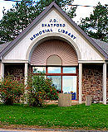

Aspotogan Arts and Crafts will be exhibiting the artwork of its members at the Shatford Memorial Library in Hubbards on a regular basis. A collection of work by AAC members was displayed during the library’s 50th anniversary celebrations.

